Dear Reader,

This document describes contents of the CD accompanying the book – Composing Mobile apps. The CD contains two folders – *3CheersCable App* and *Code Snippets from Book*, as shown in Fig. 1.

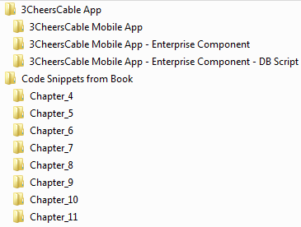

**Figure 1**. Contents of the CD

1. **3CheersCable App:** This folder contains the reference app - 3CheersCable app that has been incrementally built in *Let’s Apply* sections across the chapters of the book. This folder contains three subfolders:
   1. **3CheersCable Mobile App**: This folder contains the incremental builds of the 3CheersCable Android app.
   2. **3CheersCable Mobile App - Enterprise Component**: This folder contains enterprise counter part of the 3CheersCable Android app.
   3. **3CheersCable Mobile App - Enterprise Component - DB Script**: This folder contains the MySQL scripts required for the back end of the enterprise component of the 3CheersCable Android app.

The configuration and deployment of the 3CheersCable mobile app and its enterprise components are described in the *3CheersCable Application Deployment Guide* document in the 3CheersCable App folder.

1. **Code Snippets from Book:** This folder contains the code snippets discussed over the course of this book. This folder comprises chapter wise subfolders, each containing relevant code snippets. This folder also contains the *Snippet Arrangement.xls* file which describes the co relation between the code snippet in the book and that in the CD. Table 1 is a partial representation of the tables inside the Snippet Arrangement file. .

**Table-1.** Partial representation of contents of Snippet Arrangement file

|  |  |  |  |
| --- | --- | --- | --- |
| BOOK | | CD | |
| Snippet number | Snippet Caption | App Name | File in App |
| Snippet 5-1 | Counter functionality in a thread | Snippet5-1 | CounterActivity.java |
| Snippet 5-2 | Counter functionality in an AsyncTask | Snippet5-2 | CounterActivity.java |

*Snippet number* and *Snippet Caption* columns of this table refer to the code snippet in the book. *App Name* and *File in App* columns point to the location of the snippet in the CD. For example, the source code discussed in Snippet 5-1 (Chapter 5) with caption “Counter Functionality in a thread” can be found in the CounterAcitivity.java file of Snippet5-1 app in the CD.

Happy reading!